Log into your appointment

1. Your appointment will be in your emails.
Your therapy service will send it to you.


2. Click on the highlighted link
https://city-ac-uk.zoom.us/j/84965847168?pwd=Js94l0qVba8VlIJ0FcG67Lz5tr4Jvq.1

3. Click on the blue button
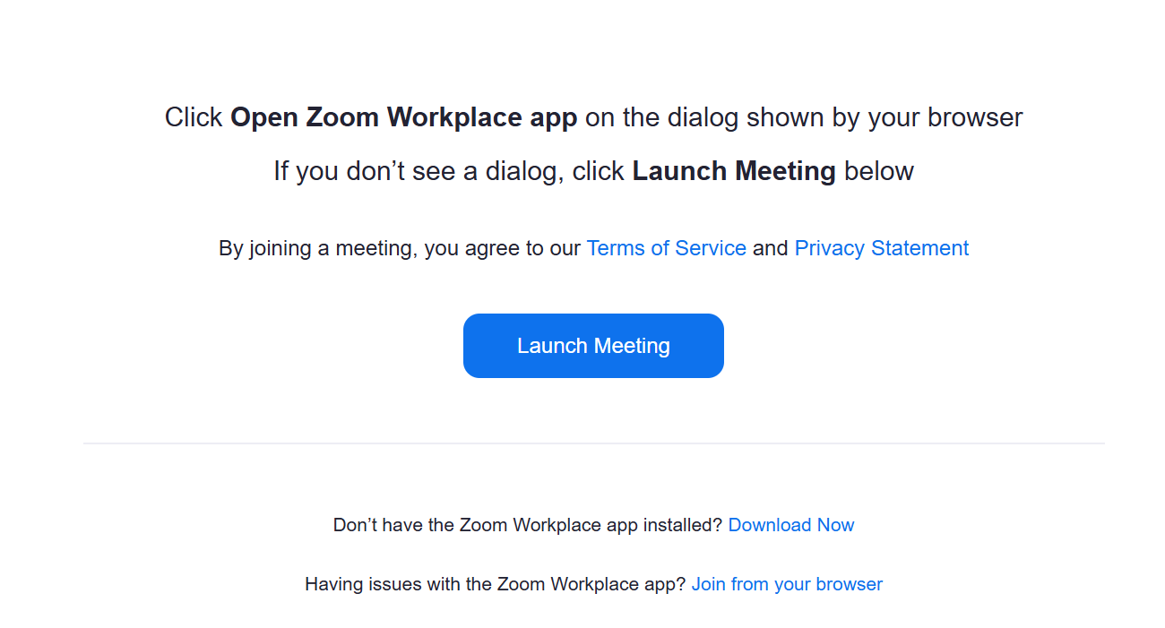
4. Click Join
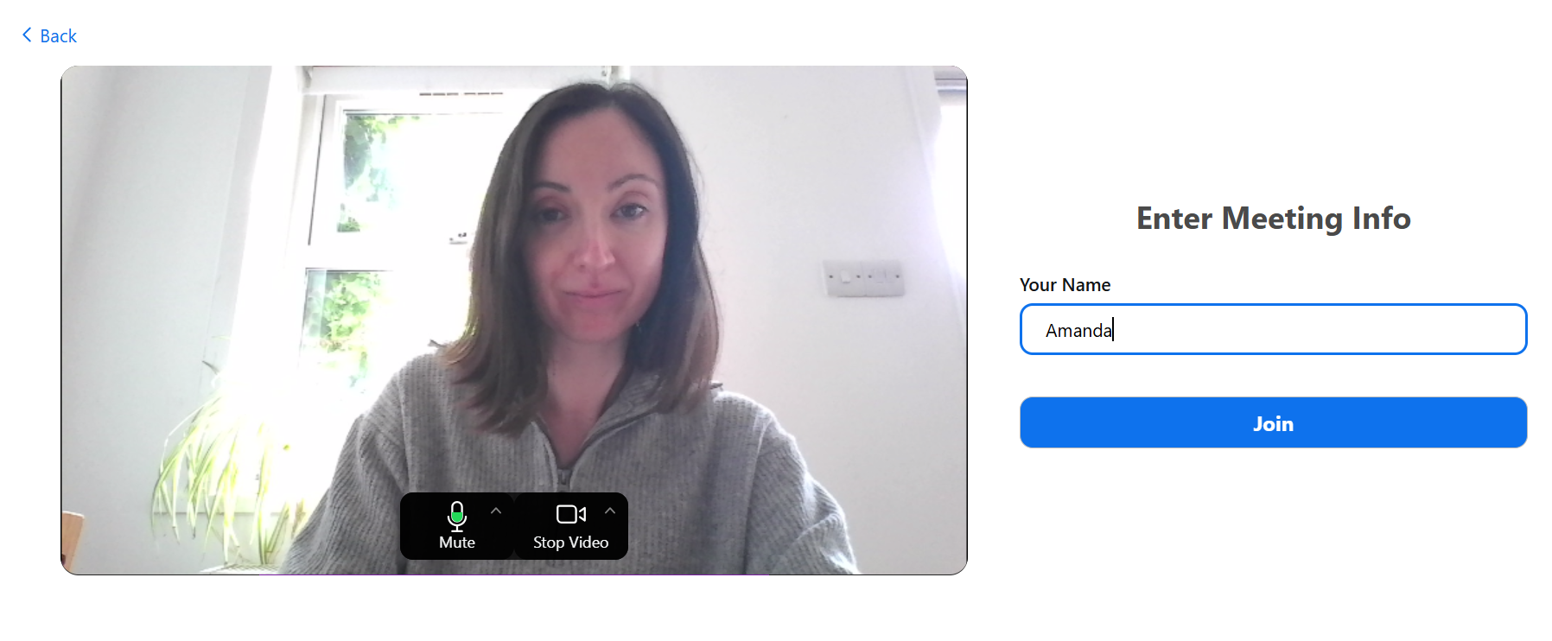

5. Wait for your therapist to start the appointment.
It will start soon.


