Log into your appointment

1. Your appointment will be in your emails.
Your therapy service will send it to you.


2. Click on the highlighted link
Join the meeting now

3. Click the purple button
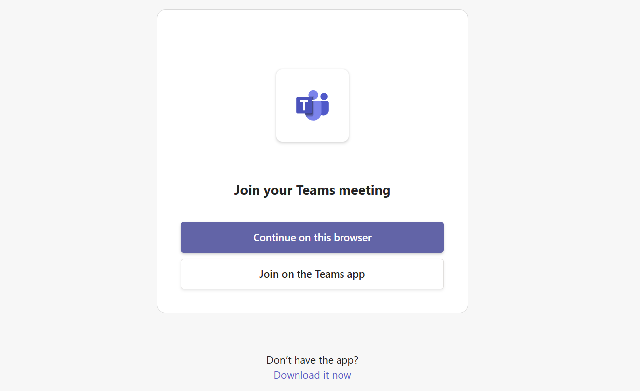

4. Click Join now
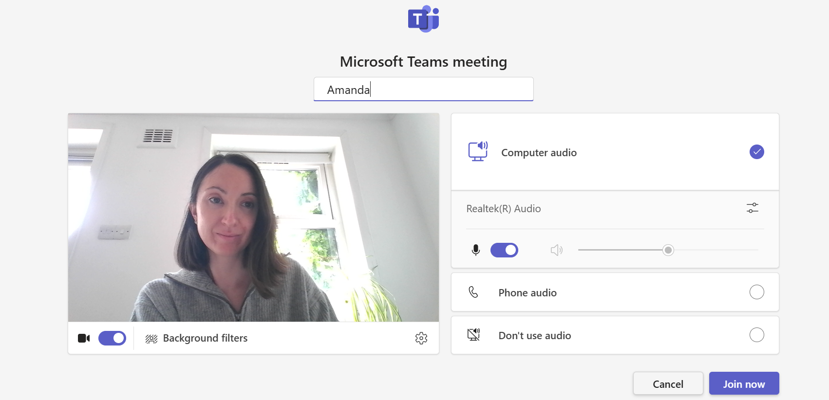

5. Wait for your therapist to start the appointment.
It will start soon.


